Battery Range and Adoption Patterns of Electric Vehicles: Using Washington State Registration Data
Aditya Kesarkar
MSc Business Analytics

Abstract
The adoption of electric vehicles (EV) is accelerating, but two important issues have not yet been adequately addressed: first, no reliable tools exist to predict the EV battery range from the vehicle characteristics to help consumers or policy makers; and second, EV adoption in rural areas is lagging behind urban areas, but this gap has not been well quantified. This study tackles both these problems, based on the Washington State vehicle registration data set of 280,833 vehicles. The study includes items including model year, manufacturer, electric vehicle type, area classification, and Clean Alternative Fuel Vehicle (CAFV) eligibility. Exploratory data analysis indicates that BEVs dominate the total number of EVs registered (80.2%), urban regions have the highest share of EVs registered (93.9% of all) and that average EV range has been consistently increasing from 2011 to 2020. Four supervised regression models are trained and tested: Linear Regression, Decision Tree, Random Forest and XGBoost.

Table of Contents
Abstract 2
Table of Tables 6
Table of Figures 7
CHAPTER 1: INTRODUCTION 8
1.1 Background 8
1.2 Significance of the Study 9
1.3 Research Questions 9
1.4 Research Objectives 10
1.5 Hypotheses 10
CHAPTER 2: LITERATURE REVIEW 11
2.1 Introduction to the Literature 11
2.2 Socioeconomic and Behavioral Determinants of EV Adoption 11
2.3 Charging Infrastructure as a Structural Determinant 12
2.4 Urban and Rural Disparities in EV Adoption 12
2.5 Battery Range as a Research Variable 13
2.6 Machine Learning Approaches to EV Prediction Tasks 14
2.7 Justification for Regression Design and Model Selection 15
2.8 Washington State as Research Context 16
2.9 Summary 16
CHAPTER 3: RESEARCH METHODOLOGY 17
3.1 Research Design 17
3.2 Data Sources/Collection 17
3.3 Data Preprocessing 18
3.4 Feature Engineering 18
3.5 Model Training and Evaluation 19
3.6 Evaluation Metrics 19
3.7 Ethical and Methodological Limits 19
CHAPTER 4: DESIGN SPECIFICATION AND IMPLEMENTATION 21
4.1 System Architecture Overview 21
4.2 Data Pipeline and Artifact Generation 21
4.3 Prediction API Design 22
4.4 Design Adoption API Design 22
4.5 Frontend Interface Implementation 23
CHAPTER 5: RESULTS AND FINDINGS 24
5.1 Overview 24
5.2 Data Quality and Missing values 24
5.2 Data Quality and Missing Values 24
5.4 Electric Vehicle Type Distribution 25
5.5 Manufacturer Distribution 26
5.6 EV Adoption Trend Over Time 27
5.7 Area Type Distribution 27
5.8 BEV versus PHEV Adoption by Area Type 28
5.9 Electric Range by EV Type 29
5.10 Electric Range by Manufacturer 29
5.11 County-Level Adoption 30
5.12 CAFV Eligibility Distribution 31
5.13 Urban versus Rural Adoption Over Time 31
5.14 Average Electric Range by Manufacturer 32
5.15 Average Electric Range Trend by Model Year 33
5.16 Correlation Analysis 33
5.17 Model Performance Comparison 34
5.18 Actual versus Predicted Values 35
5.19 Feature Importance 36
5.20 Residual Analysis 36
5.21 Web Application Deployment 37
CHAPTER 6: DISCUSSION 39
6.1 Discussion of Exploratory Results 39
6.2 Trend and Composition Effects of the Average Range 39
6.3 Model Performance and Selection 39
6.4 Feature Importance Implications 40
6.5 Application Deployment Validation 40
6.6 Fit to Research Questions 41
CHAPTER 7: CONCLUSION, LIMITATIONS, AND FUTURE WORK 42
7.1 Conclusion 42
7.2 Limitations 43
7.3 Future Work 43
References 45

Table of Tables
Table 1 Regression model performance comparison. 34

Table of Figures
Figure 1 Three-tier system architecture. 21
Figure 2 Missing values by column. 24
Figure 3 Bimodal electric range distribution (n=101,283). 25
Figure 4 EV type split: BEV 80.2% vs PHEV 19.8%. 26
Figure 5 Top 15 manufacturers by registrations. 27
Figure 6 Annual EV registrations by type (2011–2025). 27
Figure 7 EV registrations by area type. 28
Figure 8 BEV vs PHEV by area type. 29
Figure 9 Electric range by EV type. 29
Figure 10 Electric range by top 10 manufacturers. 30
Figure 11 Top 10 counties by EV registrations. 31
Figure 12 CAFV eligibility distribution. 31
Figure 13 Urban vs rural EV adoption (2011–2025). 32
Figure 14 Average electric range by manufacturer. 32
Figure 15 Average electric range by model year. 33
Figure 16 Pearson correlation heatmap. 34
Figure 17 Regression model performance comparison. 35
Figure 18 XGBoost actual vs predicted values. 36
Figure 19 XGBoost feature importance. 36
Figure 20 XGBoost residual distribution. 37
Figure 21 Web application predictor tab output. 38

CHAPTER 1: INTRODUCTION

1.1 Background
In recent years, EVs have become a key part of the global approach to decrease carbon emissions and shift the transportation sector to sustainable mobility. The global PHEV and BEV fleet has been very dynamic and is increasing exponentially in the last 10 years with uptake now gathering pace in North America, Europe and some parts of Asia (Jung et al., 2023). Washington State has always been one of the most advanced states in the United States when it comes to EV adoption, with its support of state-level incentives, expanding EV charging stations, and consumers' increased awareness of the benefits of EVs for the environment (Gifford and Barbier, 2025).
Even with this expansion, there are still unequal geographic distribution of EVs. Hardaway et al. (2025) found that there are significant disparities in EV adoption rates between urban and rural areas, with urban populations showing higher rates, which can be attributed to various factors such as access to charging stations, income, and commuting distance. At the same time, battery range anxiety remains one of the most common barriers for EVs to be more widely adopted by consumers, who are concerned with how far an EV will go on a single charge (Forsythe et al., 2023). Rural drivers and older adults, who are more likely to drive longer distances, experience greater range anxiety with their EV use, and may not have the ability to charge at home (Eby et al., 2025).
Studying these dynamics is very possible in the context of Washington State. Researchers can access detailed information on the vehicle level, including manufacturer, model year, electric range, geographic location, and the vehicle's status as a Clean Alternative Fuel Vehicle (CAFV) with more than 280,000 registered electric vehicles and a well-maintained public dataset provided by the Washington State Department of Licensing (Yu, 2025). This data can be used to model the range of batteries, as well as describe the adoption patterns of batteries in rural and urban areas. One of the state's policy environments namely a clean electricity standard, and historically low electricity prices resulting from hydroelectric generation is exceptionally supportive of battery electric vehicle ownership (Gifford and Barbier, 2025).
Transportation data is known for its complexity, and machine learning techniques have been successful in modeling complex, nonlinear relationships in transportation data. Random Forest and Gradient-Boosted Trees are ensemble methods used in various transportation research applications like energy consumption estimation, EV ownership prediction and range prediction (Achariyaviriya et al., 2023; Kaya, 2025). Very little work, however, has been done to integrate the range prediction of batteries with the spatial adoption pattern analysis in a single platform. To fill this gap, this study develops a XGBoost regression model to capture the trends of adoption and predictions and a real-time Flask-based web application for interactive exploration of both predictions and trends by county in Washington State.
This study's data set consists of 280,833 vehicle registration records from the Washington State EV Population Dataset and a second one includes vehicle registration data by vehicle class and county from fiscal years 2017 through 2026. The mixture of both sources contributes to both machine learning objectives and adoption analysis in the longitudinal approach, which provides solid empirical grounds of the research.

1.2 Significance of the Study
This study is important for two reasons: to help build predictive tooling for EV range and to offer counties information for analysis to help understand the disparity in EV adoption between urban and rural counties across Washington State.
The technical specification, battery range, is a characteristic that differs greatly according to different manufacturers, different types of vehicles, different model years, and eligibility. The ability to accurately forecast the range using these attributes is valuable for consumers when deciding to buy an EV, for policy makers creating incentive programs and for researchers analysing EV performance trends (Kaya, 2025). While range has been studied as a determinant of adoption behavior in the past (Zaino et al., 2024), systematic machine learning approaches that are targeted specifically toward range prediction within a population level registration dataset are limited. To overcome this, the present study trained, evaluated, and deployed a regression model which can be directly applied to real vehicle configurations.
From an adoption analysis point of view, it is important to understand the difference in EV adoption rates between urban and rural areas, for an equitable transportation policy. Research has found that a lack of charging infrastructure, geographical distance to work, and the average income per household have been barriers for EV adoption in rural areas (Gifford and Barbier, 2025; Lee et al., 2025). This study also combines a vehicle registration dataset from fiscal years 2017 to 2026, creating a longitudinal perspective on the changes in these gaps over time, which can be used to help build evidence to support targeted rural electrification policies.
The deployment of findings in an interactive web application is a third contribution. In addition to presenting the results in a traditional academic format, the application allows users to query the trained XGBoost model in real-time and visualize adoption over time and by geographic filter to make it easy for stakeholders to use beyond the academic world.

1.3 Research Questions
The following are the research questions that will help guide the study:
RQ1: What is the accuracy of the supervised regression models in predicting the range of an EV as registered in Washington State based on the attributes of the vehicle (model year, manufacturer, type of EV, area, and Clean Alternative Fuel Vehicle status)?

RQ2: What is the rate of EV adoption in Washington State from FY17 to FY26 and what are the differences in EV registration growth between urban and rural counties?
RQ3: Of the four regression models (Linear Regression, Decision Tree, Random Forest, and XGBoost), which model is best at predicting the electric range of EVs registered in Washington State based on the three metrics R-squared, MAE, and RMSE on a held-out test set?

1.4 Research Objectives
The study has the following objectives:
Objective 1: To perform exploratory data analysis on the Washington State EV Population Dataset to see if there are patterns in battery range and in vehicle type, manufacturer, and geographic area classification.
Objective 2: To use categorical and continuous vehicle attributes to engineer features and train four supervised machine learning regression models to predict electric range.
Objective 3: To compare the performance of the models by using the values of R-Square, Mean Absolute Error and Root Mean Squared Error to select the best model for deployment.
Objective 4: To analyze EV adoption trends, by urban and rural counties, using the Washington State Vehicle Registrations by Class and County dataset, FY 2017 – 2026.
Objective 5: To integrate the chosen predictive model and adoption analysis features in a Flask based Web application available in a web browser.

1.5 Hypotheses
H0: Vehicle attributes (model year, manufacturer, electric vehicle type, area classification, and CAFV eligibility) do not significantly predict the distance an electric vehicle can travel on a single charge among Washington State registered EVs, and no single regression model achieves an R-squared value greater than 0.85 on the held-out test set.
H1: Among the Washington State registered EVs (R² > 0.85), Vehicle attributes (model year, manufacturer, electric vehicle type, area classification, and CAFV eligibility) are significant predictors of travel distance on a single charge and XGBoost outperforms linear regression, decision tree, and random forest because it captures nonlinear interactions among features and sequentially corrects its own errors.

CHAPTER 2: LITERATURE REVIEW

2.1 Introduction
As the EV sector has grown, so has academic research on EV adoption and battery performance. Along with commercial growth, the academic body has expanded its research on EV adoption and battery performance since the early 2010s. This includes work in the field of transportation engineering, environmental economics, spatial analysis and applied machine learning. The literature could be summarized into three categories: studies on behavioral and socioeconomic factors to explain adoption, studies on geographic and spatial analyses to represent adoption patterns, and studies on the use of computational methods on EV data to predict and model the performance of EV.
The initial research of early adopters concentrated mainly on the attitude of consumers towards EVs, income sensitivity, and range anxiety, as these are major concerns for EV adoption (Mpoi et al., 2023). Recent studies have moved towards quantitative and spatial modeling as adoption data has become increasingly public and available for large-scale analysis, allowing for regression-based, machine learning models to be developed and applied to the adoption of adoption rates at the ZIP code, county and state level (Wong et al., 2025; Qian and Gkritza, 2024). This current study falls in the middle of these three, using a machine learning method to predict ranges and a spatial adoption analysis based on registration data submitted to Washington State.

2.2 Socioeconomic and Behavioral Determinants of EV Adoption
Much work has been done to understand factors that influence EV adoption over various scales of aggregation from the household to the ZIP code and county. Some determinants (such as income, education and environmental attitudes) have been found to be stable across geographic settings.
When controlling for charging infrastructure density, Sinton (2022) determined that income and educational attainment at the ZIP code level were highly correlated with EV adoption rates, where higher income and education levels were correlated with increased EV adoption rates. Lee et al. (2025) continued this research by calculating the racial and income gaps in EV adoption and the distribution of charging stations in the United States, and concluded that census areas with majority-minority and lower-income populations across the country were systematically under-served in terms of both EV adoption and charging station distribution. This equity dimension is directly connected to Washington State, where King County has high adoption rates, and lower income rural counties have significantly lower adoption rates (Esmaili et al., 2024).
One of the key factors has been identified as state policy, which is an enabler of adoption rates. Mekky and Collins (2024) applied panel data analysis to prove that the policies of states such as tax credits, HOV lane access, and registration fee exemptions have had a significant effect on EV adoption, which lasts for more than a few years after the policies are introduced. Washington State is often referred to in this regard because it was an early adopter of sales tax exemptions for EVs, and has progressive clean energy laws (Gifford and Barbier, 2025). Gifford and Barbier (2025) found in particular that commuting time and access to charging stations at the workplace were key county-level factors in adoption in Washington State, with counties with longer commute distances and fewer charging station locations at work having lower adoption rates.
Perception of consumers also influences the adoption dynamics. Gustafson and Clark (2026) analysed the content of EV advertisements to see how advertisements shifted from environmental to performance and convenience messaging, suggesting a strategic shift from EV manufacturer targeting environmentally motivated consumers to mainstream consumers. Analyzing the sentiment of public EV perception across both space and time, Qian and Gkritza (2024) discovered that EV perception sentiment was higher in the parts of the country that are typically associated with the early stages of adoption, and that there was a relationship between sentiment scores for EV perception and geographic and demographic differences reported in other studies.

2.3 Charging Infrastructure as a Structural Determinant
Access to charging stations is always a structural factor influencing EV adoption, and is often highlighted as a factor driving the disparity in EV uptake between rural and lower income areas. Powell and Johnson (2024) investigated charging station reliability and geographic location, and identified that perceived unreliability and geographic coverage gaps reduced EV adoption even for those that were interested in buying an EV. Stations with longer outages and stations that had to be passed to get to a different station were correlated with low adoption rates in adjacent ZIP codes.
Despite the high EV adoption rate in King County, WA, Esmaili et al. (2024) found that there was significant spatial inequity in the density of public charging stations in census tracts with lower-income areas having fewer public charging stations than higher-income areas. This discovery illustrates the differences within the county that may be missed if data is broken down into just urban and rural categories, and confirms the need to use very detailed spatial analysis in EV infrastructure studies. Hardaway et al. (2025) designed a built environment framework to consider how land use patterns and road and residential density work together to buffer the effects of infrastructure investments on EV adoption outcomes, and how lack of direct efforts to mitigate the structural differences between rural and urban areas will limit EV adoption in rural areas.
Another interaction between temperature and climate that has been shown to affect adoption is how charging behavior and perceived range change due to the temperature. Cervini et al. (2024) analyzed how temperature affects EV adoption at the ZIP code level in the United States and determined that cooler areas in the United States have lower EV adoption rates partly due to the impact of cold weather on EV range and range anxiety of prospective EV buyers. This climatic dimension makes range prediction tasks more complicated, because of the mismatch between the reported range values of a manufacturer and the real range values under cold condition.

2.4 Urban and Rural Disparities in EV Adoption
One of the finding patterns that appears the most consistently in the literature is the urban-rural divide in EV adoption. Factors that support adoption in urban areas include dense charging network, small average trip distances, and increased income and education levels (Hardaway et al., 2025). For this study, the urban counties are those that are part of Census Bureau Metropolitan Statistical areas: King, Pierce, Snohomish, Spokane, Clark, Thurston, Whatcom, Kitsap, Benton, Franklin, Yakima, Cowlitz, Skagit, and Walla Walla counties. All other Washington State counties are considered to be rural, with this binary classification being similar to that used in previous Washington State adoption studies (Gifford and Barbier, 2025).
As demonstrated in the exploratory data analysis performed in this study, the urban-rural disparity is quite large in the Washington State data set, with urban area registrations comprising 93.9% of the total EV registrations while rural area registrations made up 6.0%. This distribution pattern is in line with the adoption diffusion theory which states that the adoption of innovations occurs in a gradual and specific process that spreads from high-density urban centers to the periphery at a much slower pace as stated by Jung et al., 2023. As a similar high adoption state with dense urban populations compared to low adoption suburban and rural areas, Gehrke and Reardon (2022) observed that EVs were being adopted most rapidly in dense urban areas, and diffusion to the suburban and rural regions lagged significantly, a pattern that seems to be supported by registration data in Washington State.
Lukuyu et al. (2024) explored the impacts of EV adoption on the infrastructure of urban grid systems in African cities, and found that cities are experiencing high EV urbanisation levels, which pose challenges for electric grid demand management that could further discourage EV adoption if not met with a proportional expansion of electric grid capacity. Although not geographically part of Washington State, this study confirms the importance of geographic disaggregation in the study of adoption, which is implemented in the present study through the urban-rural analysis.

2.5 Battery Range as a Research Variable
Battery range has a double nature in the EV literature; it is a technical performance indicator, as well as a psychological adoption behavior indicator. Many studies have identified range the concern that the EV's battery will not manage to get them to their destination as a major obstacle to EV adoption (Zaino et al., 2024; Eby et al., 2025). In their study, Eby et al. (2025) looked in particular at range anxiety among older drivers, and found that this age group had greater anxiety about a vehicle's range even if they drove the distances typical of modern BEVs.
Using data from the National Academy of Sciences, Forsythe et al. (2023) examined the correlation between the advancement of technology and the uptake of EVs and found that among the most important technological factors that will accelerate EV uptake is an increase in battery range. Every improvement in reported range decreased the perception of range issues for consumers, especially for rural and long-distance commuters who are most affected by range. Theoretically, this discovery supports the use of an electric range as a predictor of the adoption in the current study since an improvement in the predicted range directly reduces the anxiety barrier mentioned in the adoption literature.
Using a large-scale data set, Zhao et al. (2023) calculated the actual range of EVs in the U.S. and found that EVs always exceeded PHEVs in terms of actual mileage, and that the mileage reported by the EV appeared to be well correlated with the actual patterns of vehicle use. This correlation can help with the use of the manufacturer-reported range field in the Washington State registration dataset as a useful and realistic prediction target. Cui et al. (2022) investigated the actual energy consumption of batteries in real driving conditions using vehicle sensor data, and concluded that the actual energy consumption was different from the manufacturers' specifications when driving in adverse conditions. This is recognized in the present study as it models reported range, not the dynamic range.

2.6 Machine Learning Approaches to EV Prediction Tasks
As a huge volume of EV data became available with the widespread rollout of EV registration and telematics data, the use of machine learning to analyse this type of data has also surged. Different approaches have been used for various applications such as estimating the amount of energy consumed, predicting ownership, predicting range, market segmentation and so on.
By evaluating various machine learning algorithms on various vehicle sensor data for energy consumption estimation, Achariyaviriya et al. (2023) have found that the gradient-boosted algorithms consistently performed better than the linear algorithms, owing to the ability to model the nonlinear relationship among the vehicle attributes, speed and energy output. The advantage of the gradient boosting over the linear regression in this context directly parallels the advantage that XGBoost had in the present study over linear regression on the Washington State range prediction problem: an R-squared of 0.9901 versus an R-squared of 0.7772, respectively.
Kaya (2025) applied various machine learning algorithms to EV market data from the Turkish EV market and compared the accuracy of these models, concluding that the models which are ensemble methods like Random Forest and XGBoost are more accurate than the linear models and the single tree models when categorical variables such as manufacturer and vehicle class are added. In the present study, it was found that the encoding of categorical variables – in this case Make – was a crucial pre-processing step to achieve a high performance on the tree-based models. This validates the feature engineering approach taken in this study.
Yu (2025) used data science methods to the Washington State EV ownership data, performing ownership trend analysis and predictive modelling using EV registration data. The present study and Yu (2025) rely on the same public data infrastructure provided by the Washington State Department of Licensing and confirm that the data is rich in analytical information and is reproducible. The clustering analysis results found by Henderi et al. (2025) indicate that there are significant differences among the EV market profiles, with distinct differences in range needs and EV adoption drivers between the various segments, which further supports the concept of segmenting the analysis of EV adoption by area type.
Jung et al. (2023) applied an exponential growth model to simulate the time series of BEV adoption, and obtained a typical S-curve diffusion curve shape for most major markets. Identification of exponential growth phases has implications for the longitudinal adoption analysis performed in the present study over the fiscal years 2017–2026, as the Washington State data could be an early phase of rapid growth and then a plateau dynamic in urban areas, and a later-stage of diffusion in rural areas.

2.7 Justification for Regression Design and Model Selection
The regression method is used as the main method of analysis in this study due to the type of variables being measured in this study. Electric range is a continuous quantitative variable (which in the Washington State data set is measured in miles) with a range from a few miles for some older PHEV models to more than 300 miles for the long-range BEV models. The classification methods would need to somehow discretize this continuous variable which would result in loss of information and make predictions of little practical use. It is therefore methodologically the right and academically appropriate approach for this prediction task, regression.
The data set has a combination of continuous and categorical features for model training. Model Year: Technology has advanced over time so this is a numerical variable. The target variable is the variable that is continuously measured, in this case, Electric Range. Manufacturer (Make): A nominal categorical variable grouped into 22 categories (with less than 500 manufacturers in an OTHER category) and represented as a numerical value by label encoding so that it could be used with tree based algorithms. The type of an EV (BEV or PHEV) is a binary categorical variable and coded as 1 for BEV and 0 for PHEV. Area Type is a binary categorical (1: Urban, 0: Rural) variable. CAFV eligibility is an ordinal categorical variable and the eligibility codes (2 for eligible, 1 for unknown and 0 for not eligible) are integer codes. A combination of this feature set makes the ensemble tree methods more appropriate than linear models, as categorical encodings often do not make linear model assumptions about the distribution of features (Kaya, 2025).
Linear Regression is used as a baseline model among the four models which is trained; however, it does not make theoretical sense when the range is dependent on the interplay between manufacturer, vehicle type, and model year. The Decision Tree Regressor is able to model the non-linear patterns, but can overfit the training set and has high variance for predictions on new data. Random Forest is a method that tackles variance by taking a number of samples, with replacement, of the data, training a tree on each, and then taking the average of the predictions. Unlike Random Forest, in XGBoost, it has a sequential bias reduction mechanism that sequentially trains each successive tree using the residual error of the previous ensemble (Achariyaviriya et al., 2023). The results of the present study demonstrated that XGBoost model had the best performance in terms of RMSE (9.64 miles) and R-squared (0.9901) on the test set, which empirically proved its superiority for this prediction task.
This study is of the quantitative type. The predictive modeling part is implemented in a cross-sectional supervised learning framework, with a train-test split of 80/20, with a fixed seed of 42 in the random number generator for reproducibility. The adoption analysis part uses a longitudinal descriptive design, which looks at registration numbers and EV adoption rates by year, and by type of area, in fiscal years 2017 to 2026. These two designs are used to answer the three research questions posed in Chapter 1 and they give a logically sound basis for the deployment of the web application.

2.8 Washington State as Research Context
Washington State is in a unique position when it comes to EV adoption research because it is a leader in policy actions, has energy economics that are favorable to EVs, and has geographic diversity in both densely populated urban areas and sparsely populated rural areas. Washington State has been identified by Gifford and Barbier (2025) as having a strong commuting infrastructure, and higher levels of access to charging at the workplace, which has led to the highest adoption rates.
Esmaili et al. (2024) identified King County as a reflection of the strengths and equity gaps of Washington State's EV network due to its high overall station density and noted that station density is relatively high for some income levels while being low for others in the county. This is especially important in the context of the present study as King County is the largest contributor to the urban EV registration data set in Washington State and the internal heterogeneity of the County may account for some of the variance in the range prediction model.
Samawi et al. (2025) and Zaino et al. (2024) give a more cross-national view of adoption barriers and enablers, and highlight that range limitations, charging infrastructure gaps and vehicle purchase costs are the three main barriers to adoption across a range of geographic settings. Solving the range prediction aspect of the constraint directly via machine learning helps reduce the information gap and range anxiety that is associated with range prediction, offering consumers and policymakers a data-driven reference for the range outcomes for different vehicle configurations.

2.9 Summary
It is found in the literature that several factors, such as technological, policy, socio-economic and spatial can affect the adoption of EVs. Range is a technical and a behavioural aspect of battery adoption and an accurate prediction is both possible and useful, and can be achieved through machine learning. According to some recent works, XGBoost is the best model for regression problems with mixed categorical and continuous variables with nonlinear interactions and relationships (Achariyaviriya et al., 2023; Kaya, 2025). It is well documented that there is an urban-rural gap in adoption and to investigate this gap is the framework for the adoption analysis component. This research follows in the footsteps of these works, presenting conceptual and methodological advances and practical policy implications in the context of Washington State registration data and predictive range modeling and longitudinal adoption analysis.

CHAPTER 3: RESEARCH METHODOLOGY

3.1 Research Design
This paper takes on a quantitative research design that incorporates a supervised machine learning element to predict battery range and longitudinal descriptive element to analyze EV adoption. The predictive modeling part is based on a cross-sectional experimental design where the feature of automotive attributes based on a single snapshot of vehicle registration are employed to train and predict regression models on a test set that is kept back. The analysis component of the adoption have a longitudinal descriptive design, which shows study the trends in the volume of EV and non-EV registration by area classification at the level of fiscal years 2017-2026.
The quantitative paradigm is suitable, since the prediction variable, which is the electric range in miles, and the adoption variables, i.e., the number of registrations and the adoption rates, are all numerical variables, which can be subjected to statistical analysis and objective assessment (Kaya, 2025). The research questions were also not suitable to be addressed in a qualitative or mixed-methods approach since they are more focused on predictive accuracy and quantifying the trend than on the subjective perceptions or motivations. The general data science pipeline is used, such as data acquisition, preprocessing, exploratory data analysis, feature engineering, model training, evaluation and deployment (Achariyaviriya et al., 2023).

3.2 Data Sources/Collection
The empirical basis of the study is two publicly available datasets which were obtained through the Washington State open data portal at data.wa.gov.
The major data is the Washington State Electric Vehicle Population Dataset that houses 280, 833 records of vehicles at the vehicle-level registration with 17 attributes such as VIN prefix, county, city, state, postal code, model year, manufacturer, model name, electric vehicle type, Clean Alternative Fuel Vehicle eligibility status, electric range, legislative district, DOL vehicle identifier, vehicle location coordinates, electric utility, and 2020 Census Tract identifier. A preprocessing script created an AreaType column, where each record was given one of the Urban, Rural, and Unknown values, based on the city of registration against a comprehensive list of Washington State urban places based on the 2020 Census Urban Areas and Washington State Growth Management Act Urban Growth Area.
The Washington State Vehicle Registrations by Class and County dataset is the secondary data, which includes 1,468,493 records on transactions level of the fiscal years 2017-2026 with columns such as fiscal year, date of transaction, county of transaction, residential county, type of fuel, main use type, and the number of registrations. Electric vehicle registrations were isolated in the fuel type field and the residential county field was used to classify urban or rural area using a fixed list of 14 urban counties, which is the same as Census Bureau metropolitan statistical area definitions of urban counties.
Both datasets are open data and do not have any personally identifiable information on the individual level (VIN data is limited to the first ten characters and the geographic information is presented in the county or postal code level).

3.3 Data Preprocessing
Data preprocessing of the original data started by analysing the missing data in all the 17 columns. There were 12 null values in the electric range column and these were excluded. Due to the fact that the task of prediction is on vehicles having a reported electric range, all the records having electric range value at zero were filtered out and the modeling dataset was narrowed to 101,283 records. This filtering indicates that a significant percentage of PHEV registrations show a range of zero in the data since range testing was not done or not recorded on these vehicles. The records having the nulls in any of the five features columns chosen or the target column were then deleted.
Area_Type was limited to Urban and Rural to include in the modelling aspect, the 12 records with Unknown category were left out. The modeling dataset that was obtained had vehicles registered in the two classes of binary areas and the geographic dimension of the adoption analysis was maintained in the framework of the prediction.
In the case of the secondary dataset, Count column was changed to a numeric type but non-convertible values were changed to zero. The Fuel Type column was used to derive a Boolean is_ev flag and the urban list was used to classify the area by county. This ready dataset facilitates the analysis route of adoption in the Flask application.

3.4 Feature Engineering
The regression model utilized five features that were chosen based on theoretical importance in predicting battery range and were available in the data set.
Model Year is a continuous numerical variable and it represents a yearly technological progress of EV battery. Forsythe et al. (2023) formed that the progress of the model years is among the best predictors of the range improvement, which is why it should be considered one of the main features.
Manufacturer (Make) is categorical variable (nominal) that has a long tail of manufacturers that are not frequent. All makes that had less than 500 registrations in the modeling data set were placed in one other category to give 22 different categories. These categories were encoded with label encoding to get integer indices, which can be used in tree-based algorithms. The category granularity versus the risk of modeling noise presented by very small manufacturer-specific samples were used to select the threshold of 500 (Kaya, 2025).
Electric Vehicle Type is a binary variable, which is 1 in case of Battery Electric Vehicle and 0 incase of Plug-in Hybrid Electric Vehicle. This binary distinction is a theoretically grounded predictor as BEVs always have an electric range that is higher compared to PHEVs due to their use of a battery system only in contrast to the combined battery and combustion system used in PHEVs (Zhao et al., 2023).
Area Type is binary 1 Urban and 0 Rural as it is likely that there is a regional difference in the vehicle configurations registered in various geographical locations.
CAFV eligibility is an ordinal variable coded to 2, 1, and 0 which means CAFV eligible, unknown eligibility and not eligible respectively. The battery range performance benchmarks determine CAFV eligibility, hence it makes an informative proxy of the level of the vehicle range prior to modeling (Gifford and Barbier, 2025).

3.5 Model Training and Evaluation
The modeling data is divided into training and test data sets based on 80-20 split having a fixed random seed of 42 to achieve reproducibility. The training set had 80,962 records and test set had 20,241 records. It is only the training features of the Linear Regression model that is standardScaler normalized and the scaler was fitted on the training data and applied to the test data to avoid data leakage.
The four regression models were trained: Linear Regression was used as parametric baseline, the Decision Tree Regressor maximum depth of 10 and minimum 20 samples per leaf, the Random Forest Regressor 150 trees, maximum depth of 12, learning rate 0.05, subsample ratio 0.8, column subsampling ratio 0.8. These hyperparameter choices were made to find a balance between the complexity of the model and the risk of overfitting without grid search, which is in line with applied machine learning practice to large tabular data (Achariyaviriya et al., 2023).

3.6 Evaluation Metrics
Three standard regression evaluation measures were used to measure model performance. Mean Absolute Error is used to estimate the average size of the prediction errors in miles which is an interpretable measure of the common prediction error. Root Mean Squared Error magnifies bigger errors more than MAE and is therefore sensitive to outliers and forecasts that are far-off the actual range. R-squared is used to measure the percentage of variance in electric range explained by the model, and the closer to 1.0, the greater the percentage of variance the model explains. The most appropriate model was chosen as the one that obtained the greatest R-squared with the test set, which aligns with the main research goal to maximise the predictive accuracy (Kaya, 2025).

3.7 Ethical and Methodological Limits
No personally identifiable information of individuals was included in the dataset, and all the analyses were done on the aggregating statistical patterns. One of the methods limitations of the research is that the object of prediction is the electric range reported by the manufacturer and not the real-world range which is dynamically measured under adverse driving or climatic conditions (Cui et al., 2022; Cervini et al., 2024). Also, the imbalance in the type of 80-20 area of the dataset with urban records constituting 93.9% of the modeling sample implies that the model is mostly calibrated to urban vehicle configurations and can have a greater prediction error with rural area records.

CHAPTER 4: DESIGN SPECIFICATION AND IMPLEMENTATION

4.1 System Architecture Overview
The architecture of the system is a three-tier architecture that has a data and artifact layer, a server-side application layer and a client-side presentation layer. The high-level architecture is shown in figure 1.
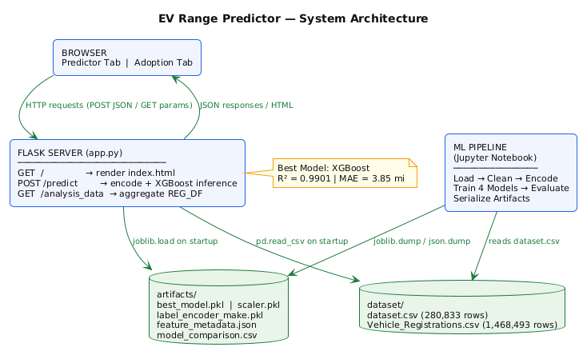
Figure 1 Three-tier system architecture.
The architecture illustrates the client-side browser interface (which interacts with the Flask application server) and the server layer (which carries out model inference and adoption data aggregation with the artifact and dataset layer) which is stored on the local file system.

4.2 Data Pipeline and Artifact Generation
The machine learning pipeline was run in a Jupyter Notebook. The pipeline takes the form of a sequence: ingesting raw CSV, analysing missing values and removing them, filtering by Area_Type, binary and ordinal feature encoding, label encoding of the Make variable, train-test splitting, model training, computing metrics, and serialising artifacts.
The joblib library is used to serialize five artifacts to the artifacts/ directory (model and encoder objects) and the json standard library is used to serialize metadata. The trained XGBoost Regressor object is saved in the best_model.pkl file, with the size of 1.28 MB, which corresponds to the size of the 200-tree ensemble. The scaler.pkl contains the StandardScaler that is fitted on the training features to work with Linear Regression. LabelEncoder fitted on the 22 Make categories are saved in the label_encoder_make.pkl. The feature_metadata.json file contains the list of features, name of the target, name of the best model, make classes and CAFV integer mapping, which allows the Flask application to recreate prediction inputs without re-importing scikit-learn pipeline objects. The model comparison.csv contains performance of all the four models, and facilitates reproducible reporting.
When the application is started, app.py loads all five artifacts into memory at the start of the application into joblib.load and load.json and loads the vehicle registration CSV into a pandas DataFrame that is stored as the module-level variable REG_DF. The eager loading approach removes per-request disk I/O, and guarantees that the response latency is the same on both API endpoints.

4.3 Prediction API Design
The /predict route takes in HTTP POSTs with a JSON body that has five fields: model,year as an integer, make as a string, ev,type as either BEV or PHEV, area,type as either Urban or Rural and cafv as a string that is one of the three CAFV eligibility labels. Server-side input validation is used to enforce that model-year must be between 1990-2030 and the out of range values result in a 400 status and a description error message. String inputs are not sanitized further than type coercion as any categorical inputs are converted to the pre-fitted LabelEncoder or explicit dictionary lookups so that any manufacturer name not recognized is put in the OTHER category instead of raising a runtime error.
The encode and predict functions create a single row NumPy array in the specific sequence of features utilized in the training: Model year, make encoded, EV type binary, Area binary, CAV code. This strict ordering of features is important to the compatibility of models using trees, because XGBoost recombines split predicates using feature index during inference. The role gives back the projected range to a single decimal spot that is encoded as the field of forecasted range of a JSON reaction.

4.4 Design Adoption API Design
The analysis_data path takes in HTTP GET requests with three optional query parameters: year_from and year_to (integers) defaulting to 2020 and 2025 and area type (string) defaulting to All. The route selects the loaded REG_DF DataFrame based on the range of fiscal years and may select based on the area classification and then aggregates EV and non-EV registration frequencies by fiscal year. The adoption rate is calculated by dividing the number of EVs by the number of total number multiplied by 100 and a zero-division guard is used where the number of registrations is zero. The response JSON was included arrays of years, ev counts, non ev counts, total counts and adoption rates, which are immediately consumed by the client-side Chart.js visualization without any further transformation.

4.5 Frontend Interface Implementation
It is implemented with the frontend being a single Jinja2 template that is rendered by the index route and the frontend uses Bootstrap 5.3 to support the responsive layout and Bootstrap Icons to support iconography. The interface is implemented using two main interface panels that are in the form of Bootstrap tab elements, which have a sticky navigation menu: Battery Range Predictor tab and EV Adoption Analysis tab.
The predictor panel displays six quick-sample cards which are already filled with realistic vehicle configurations of Tesla, Toyota, Nissan, Jeep, Ford and BMW. When a sample card is clicked, the form fields are auto-populated and a prediction request is immediately sent to minimize friction of the user interaction to demonstrate it. The result panel shows the range value suggested, a proportional range bar that was calibrated to the maximum range of 337 miles observed in the data set, a tier badge indicating a Long Range of above 250 miles, Good Range of above 150 miles, Moderate Range of above 50 miles and a summary of the parameters entered into the vehicle.
The panel of analysis of adoption creates a mixed bar and line chart with Chart.js 4.4, where EV and non-EV registration rates are plotted as grouped bars and the EV adoption rate is plotted as a dashed line, respectively, on the left and a secondary right y-axis. Four KPI cards show the number of EV registrations, number of non-EV registrations, the average rate of adoption, and the number of EVs registered the first and the final year of the selected year, calculated on the client-side of the API response arrays. The same response data is then programmatically used to generate dynamic insight text which is used to determine the highest rate of adoption in a year and the percentage point change over the range of years being used.

CHAPTER 5: RESULTS AND FINDINGS

5.1 Overview
The chapter shows the results of the exploratory data analysis of the Washington State Electric Vehicle Population Dataset and four supervised regression models that have been trained to forecast the electric range. The results are provided in a chronological order, where data quality assessment, distributional analysis, geographic and temporal patterns of adoption, model performance comparisons, and validation of deployment with the Flask web application are discussed.

5.2 Data Quality and Missing values
The first step in the examination of the 280,833-record data set was to discover that the missing data were clumped in a few columns. Legislative District had the highest number of missing records with 703 records (0.25%), followed by County, City, Postal Code, Electric Range, Electric Utility, and 2020 Census Tract with 12 records missing each (less than 0.01%) (see Figure 2). There were 20 missing values in Vehicle Location. The overall completeness of the data used was high with all the five features used in modeling having insignificant null rates. The 12 records with Electric Range absent in the filtered modeling data were eliminated and all the 101, 283 records with reported range value higher than zero were used to train the model.
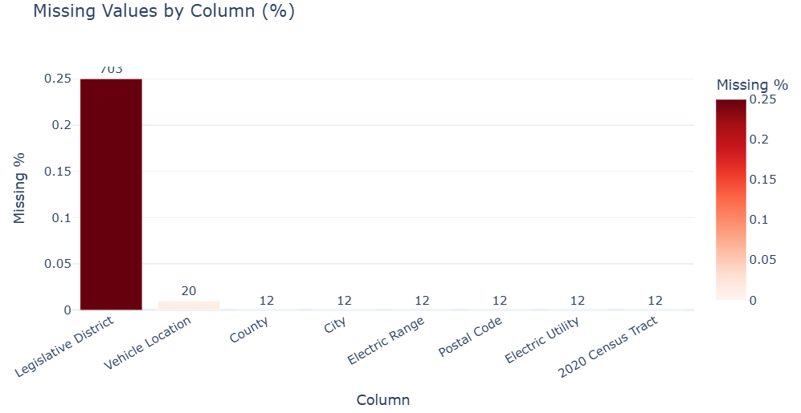
Figure 2 Missing values by column.

5.2.1Data Quality and Missing Values
Figure 3 shows the distribution of the electric range of all 101,283 vehicles whose range was reported to be more than zero. Distribution is bimodal, which corresponds to the basic distinction between BEV and PHEV range architectures. A big concentration of values falls between 20 and 40 miles, which is associated with PHEV registrations and a second bigger concentration is between 150 and 337 miles, which is related to BEV arrangements. The highest range recorded in the data is 337 miles, which was only in Tesla vehicles. The median of BEVs is 215 miles having a mean of 199.96 miles and PHEV records a median of 32 miles and a mean of 31.76 miles, which indicates that there is statistically significant difference between the two types of vehicles in the variable of interest.
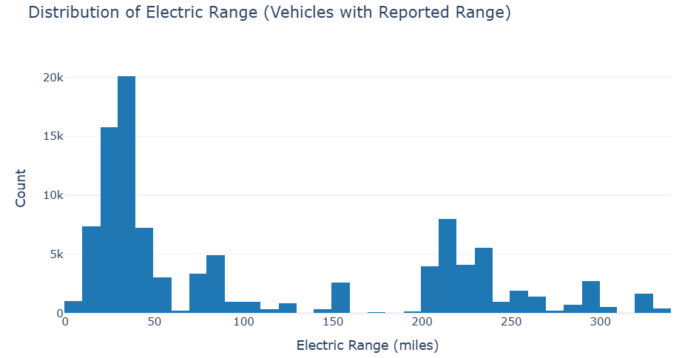
Figure 3 Bimodal electric range distribution (n=101,283).

5.4 Electric Vehicle Type Distribution
The ratio of BEV and PHEV registrations in the entire data set of 280 833 is shown in Figure 4. The number of Battery Electric Vehicles is 225,124 (80.2) and Plug-in Hybrid Electric Vehicles number is 55,709 (19.8). This large BEV market share indicates the policy environment and maturity of charging infrastructure of Washington State, which, in turn, mitigate the range anxiety barrier that would otherwise prefer PHEV adoption in less infrastructure-saturated settings (Forsythe et al., 2023).
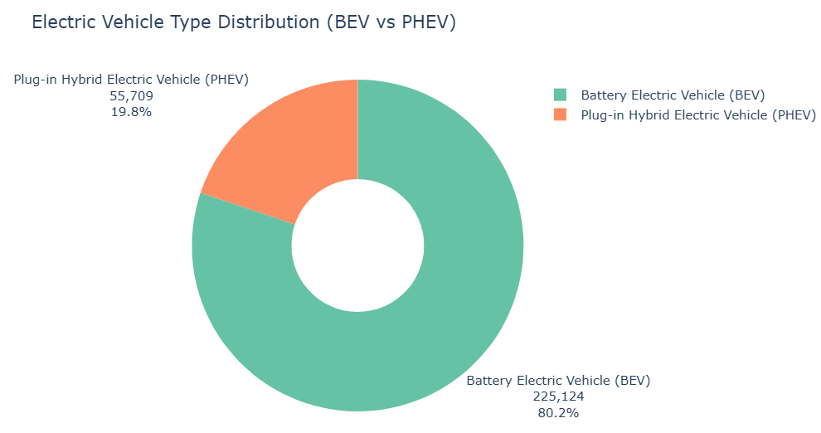
Figure 4 EV type split: BEV 80.2% vs PHEV 19.8%.

5.5 Manufacturer Distribution
In Figure 5, the top 15 EV manufacturers in terms of the number of registrations are shown. Tesla has the largest number of entries, registering 114,817 entries, which is 40.9% of the entire dataset and nearly five times the number of the second-ranked manufacturer. Chevrolet ranks second with 19,410 registrations, followed by Nissan (16,153), Ford (15,423), Kia (14,101), and Toyota (11,979). The fact that a small group of manufacturers had most of the registration warranted the decision to group manufactures with less than 500 registrations into an OTHER category since infrequent manufacturers would add noise to the label-encoded Make feature without providing significant predictive value.
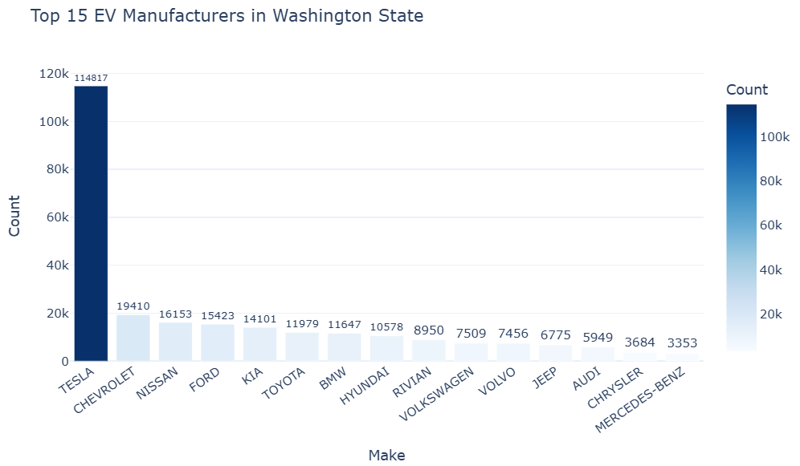
Figure 5 Top 15 manufacturers by registrations.

5.6 EV Adoption Trend Over Time
Figure 6 shows annual registration of EVs by type of vehicles by model years 2011-2025. Total registrations grew from 573 in 2011 to a peak of 60,333 in 2023, followed by 49,544 in 2024 and 36,867 in 2025. BEVs have always surpassed PHEVs in all years, but this difference has increased significantly since 2021 when the range capability and the variety of models of BEVs have increased significantly. The observed exponential growth phase (2017-2023) coincides with the dynamics of diffusion reported by Jung et al. (2023).
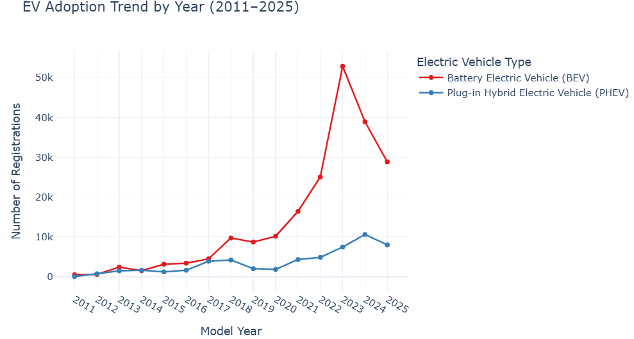
Figure 6 Annual EV registrations by type (2011–2025).

5.7 Area Type Distribution
Figure 7 shows the distribution of EV registrations by area in geography. The urban areas comprise 263,911 (93.9%), rural areas comprise 16,910 (6.0%) and 12 records are not classified. This pattern shows the rural-urban distribution of the existing concentration of EV infrastructure and income levels that enable adoption, which are well-documented (Hardaway et al., 2025). In the urban section, there are 212,129 BEVs and 51,782 PHEVs. In the rural segment, the BEVs and PHEVs have 12,985 and 3,925 registrations respectively.
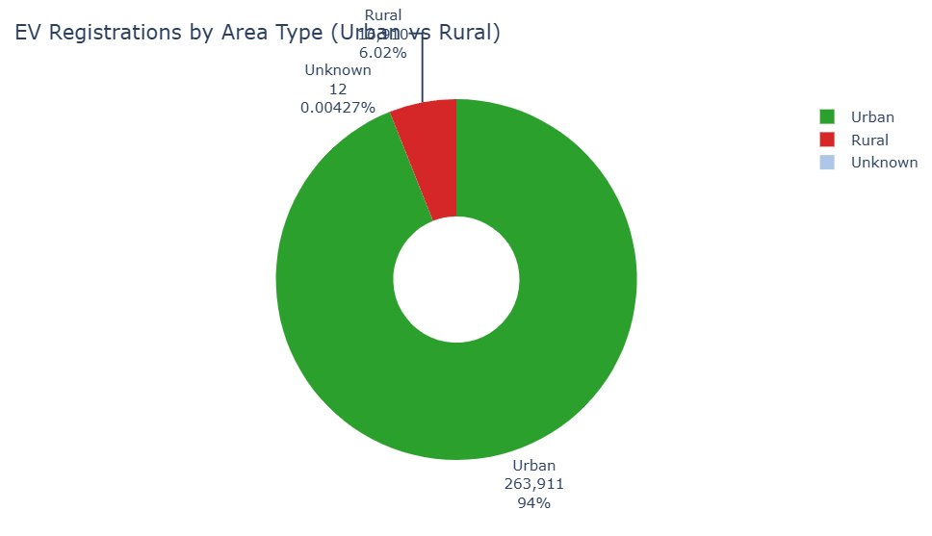
Figure 7 EV registrations by area type.

5.8 BEV versus PHEV Adoption by Area Type
In Figure 8, a grouped bar chart of the BEV and PHEV registration numbers in urban and rural categories is given. The ratio of BEV to PHEV in urban places is around 4.1:1 whereas in rural places it is 3.3:1. The rural comparatively higher relative PHEV share can be attributed to the assumption that range anxiety have a stronger impact in rural locations, where charging infrastructure is less concentrated, and therefore some rural purchasers may be swayed by hybrid choice (Gifford and Barbier, 2025).
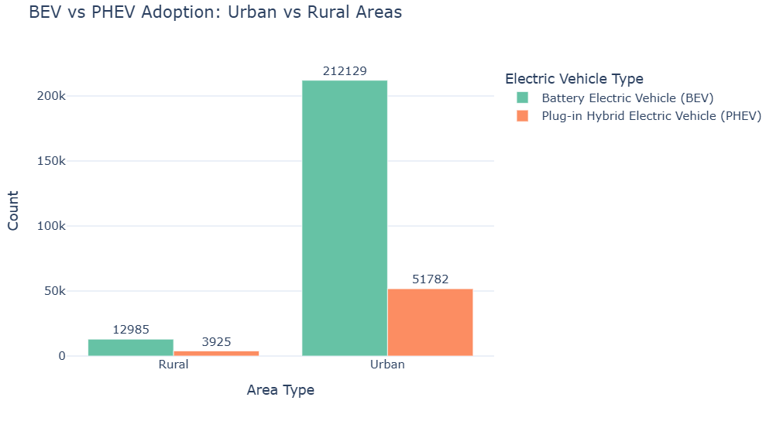
Figure 8 BEV vs PHEV by area type.

5.9 Electric Range by EV Type
Figure 9 shows box plots of the distribution of electric range of both types of vehicles: BEV and PHEV among the records that have a reported range. The BEV records have a median of 215 miles, and an interquartile range of 150-239 miles with a maximum of 337 miles. According to PHEV records, it has a median of 32 miles with the interquartile range of 21 to 38 miles. This was confirmed by the fact that the two distributions almost have no overlap at all, which indicates that the type of the electric vehicles is the most discriminative single predictor of the range in the dataset, and it should be encoded as a model feature in binary.
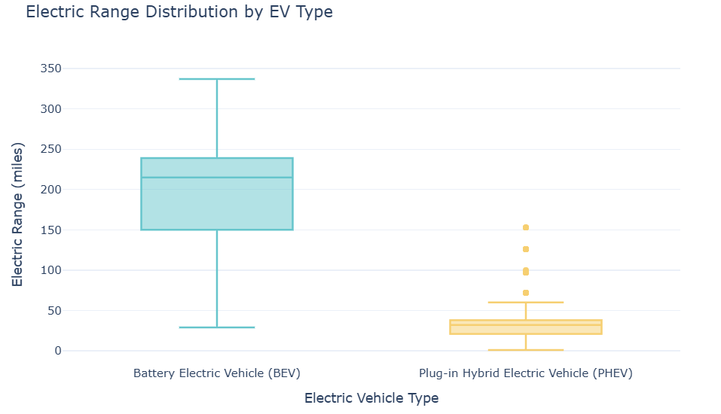
Figure 9 Electric range by EV type.

5.10 Electric Range by Manufacturer
Figure 10 is a boxplot of the 10 leading manufacturers in terms of registration number of vehicles that have a reported range. The median range of Tesla is the largest (around 220 miles) with the interquartile range between 215 and 270 miles with the highest maximum value of 337 miles representing the long-range Model S and Model X models. Nissan and Chevrolet have moderate median ranges, representing the BEV and PHEV product portfolios as a whole, whereas Toyota, Kia, BMW, and Hyundai have compressed interquartile ranges, which are indicative of BEV-focused portfolios of the registration data. This difference on the manufacturer level validates the hypothesis that the label-encoded Make factor contains independent predictive information on top of EV type alone.
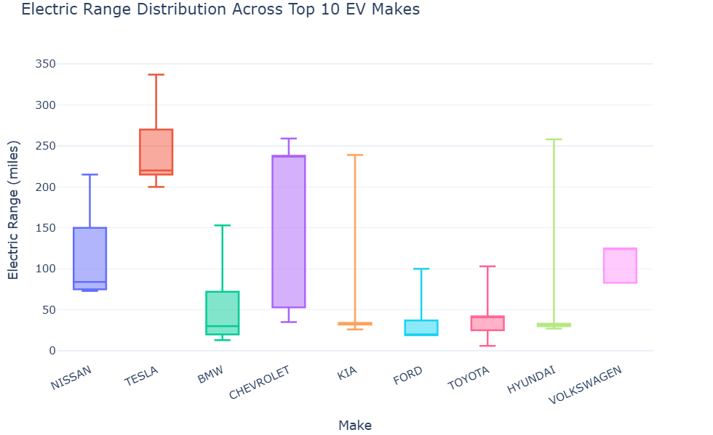
Figure 10 Electric range by top 10 manufacturers.

5.11 County-Level Adoption
Figure 11 shows the 10 counties with the highest number of EVs registered. King County has the highest number of 138,276 registrations, which constitutes 49.2% of the total number of records. Snohomish ranks second with 35,137, followed by Pierce (23,041), Clark (17,315), Thurston (10,220), and Kitsap (9,563). All the top ten counties qualify as urban based on the definition of the counties under the county-level metropolitan statistical area used in the research. This density is in line with the adoption infrastructure analysis performed by Esmaili et al. (2024) of King County in particular, and supports the trend of urban dominance in the area type analysis.
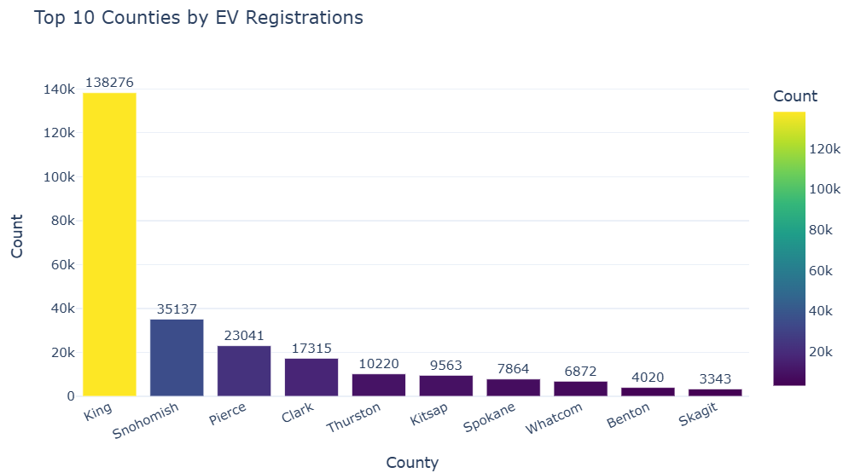
Figure 11 Top 10 counties by EV registrations.

5.12 CAFV Eligibility Distribution
Figure 12 shows a distribution of Clean Alternative Fuel Vehicle eligibility status. The biggest one is eligibility unknown since battery range was not studied and covers 179,538 records (63.9%). There are 77,133 (27.5%) records of CAFV-eligible vehicles and 24,162 records (8.6%), which are ineligible because of low battery range. The preponderance of the unknown category indicates an incomplete range testing records in the state registration system, and it supports the ordinal encoding technique used by the study which codes the unknown records to the mid-range code of 1 instead of imputing the eligibility.
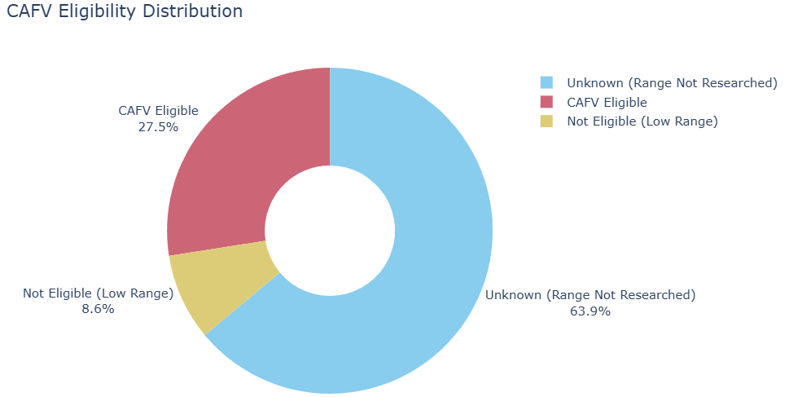
Figure 12 CAFV eligibility distribution.

5.13 Urban versus Rural Adoption Over Time
In Figure 13, annual vehicle counts of EVs registered by area type are plotted as grouped bars, for model years 2011 through 2025. The number of urban registrations is increasing steadily at first (532 in 2011) to a high of over 56,000 in 2023, rural registration is consistently lower (under 4,000 over the whole period). The absolute difference in urban and rural counts is increasing every year, which would suggest that urban to rural diffusion in adoption has not been as high to bridge the geographic gap as it would be required to close the geographic gap, aligning with the structural barriers detected in the literature (Hardaway et al., 2025).
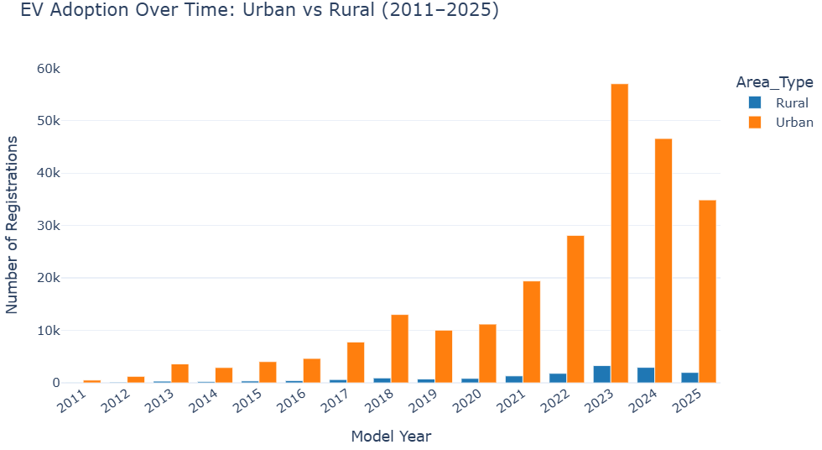
Figure 13 Urban vs rural EV adoption (2011–2025).

5.14 Average Electric Range by Manufacturer
Figure 14 shows the average of reported electric range among the top 15 manufacturers of vehicles with a reported value. Tesla has a mean range of 241.5 miles followed by Jaguar with 234.0 miles and Polestar with 233.0 miles. Chevrolet has an average of 151.7 miles indicating that the Bolt EV makes a good contribution to its range. The average Volkswagen is 107.7 and Nissan 106.2 miles. Manufacturers that have PHEV offerings as their main products, such as Porsche (93.1 miles), Fiat (85.5 miles) and Audi (75.5 miles) have lower averages.
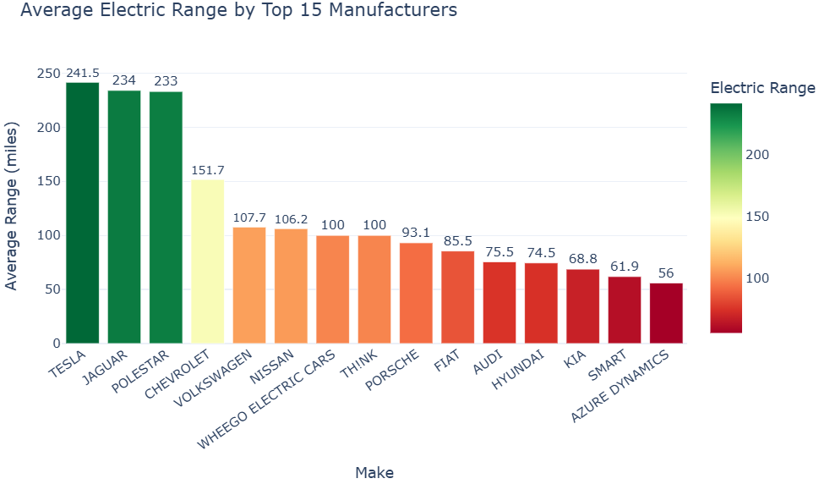
Figure 14 Average electric range by manufacturer.

5.15 Average Electric Range Trend by Model Year
Figure 15 shows the average reported electric range by model year of vehicles that reported a range of 2011-2025. The trend indicates that the growth is progressive, with the highest number of 238.2 miles, which is the highest in 2020, indicating a progressive increase of the figure since the year 2011, which is the base year, with a figure of 71.8 miles. The significant drop in the years 2021 to 2025 to an average of 52.0 miles (2021), 28.9 miles (2022), 30.6 miles (2023) and 35.2 miles (2025) is due to a data composition effect: a massive number of PHEV registrations in 2021 onward are now reporting range values in the state dataset, pushing the average closer to the lower PHEV range distribution instead of being a technological regression in battery capacity.
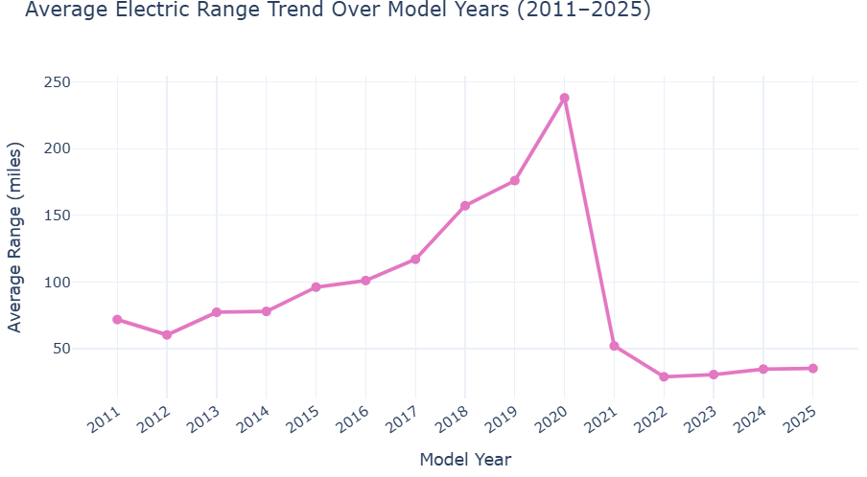
Figure 15 Average electric range by model year.

5.16 Correlation Analysis
Figure 16 shows the Pearson correlation heatmap between the four numerical columns that can be found within the dataset: Model Year, Electric Range, Legislative District, and Postal Code. Model Year demonstrates a moderate positive correlation with Electric Range, which confirms the fact that more recent vehicles are more likely to report higher ranges, which can be explained by the technological advancement hypothesis (Forsythe et al., 2023). Legislative District and Postal Code are found to have very small correlations with Electric Range, and therefore they do not contain much useful direct predictive information on range estimation and are not useful model factors.
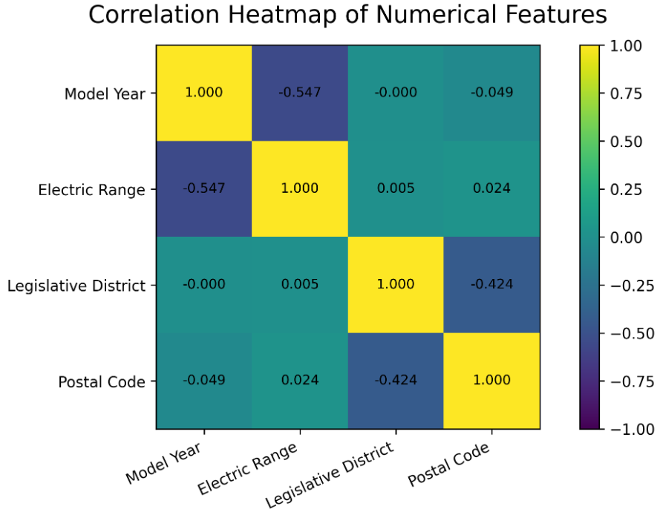
Figure 16 Pearson correlation heatmap.

5.17 Model Performance Comparison
The performance of all 4 regression models on the held-out test set of 20,241 records are shown in Table 1 and Figure 17.
Table 1 Regression model performance comparison.
Model | MAE (miles) | RMSE (miles) | R²
Linear Regression | 33.25 | 45.72 | 0.7772
Decision Tree | 3.80 | 9.82 | 0.9897
Random Forest | 3.75 | 9.80 | 0.9898
XGBoost | 3.85 | 9.64 | 0.9901
Linear Regression is significantly inferior to the three tree-based models; and its R 2, MAE, and RMSE are 0.7772, 33.25 miles and 45.72 miles, respectively. This finding proves that the dependence between the features chosen and the electric range is not linear and that a parametric linear assumption cannot be used in predicting this task. Decision Tree delivers a significant increase with an R 2 of 0.9897 and random forest increases slightly further to 0.9898 with decrease in variance using bootstrap aggregation. XGBoost has the best R2 (0.9901) and the lowest RMSE (9.64 miles), thus making it the recommended deployment model.
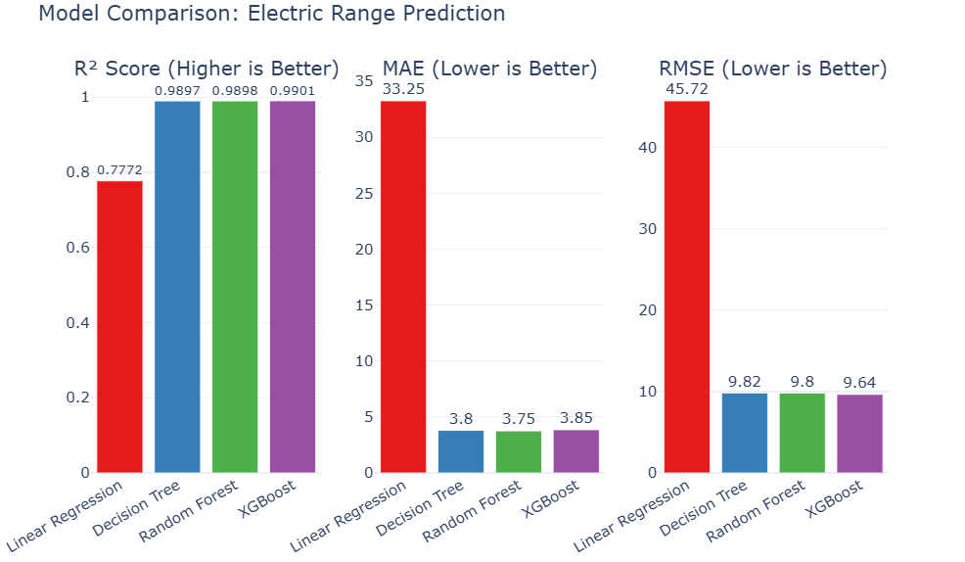
Figure 17 Regression model performance comparison.

5.18 Actual versus Predicted Values
Figure 18 shows a scatter plot of the actual and predicted values of electric range of XGBoost on the test set of 20,241 records. There is a tight concentration of points along the perfect fit diagonal, therefore, suggesting that the model is highly faithful to the large patterns in the data. The two main clusters in the scatter are the ones of the PHEV range band (0-50 miles) and the BEV range band (150-337 miles), both of which the model predicts very well. Small dispersion is observed at the high tail at around 300-337 miles, which is indicative of the difficulty in making predictions of maximum-range configurations when a data set is dominated by middle range BEVs.
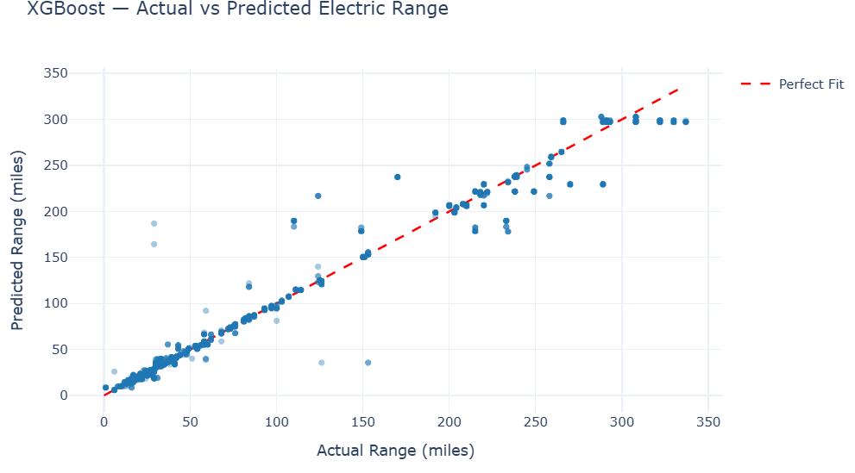
Figure 18 XGBoost actual vs predicted values.

5.19 Feature Importance
The XGBoost scores of feature importance are shown in figure 19 and indicate the relative importance of each feature to each split in all 200 trees. Make_Encoded captures the largest importance value, meaning that manufacturer identity is the one most predictive of electric range, which is in line with the large manufacturer-level range difference of the average of the range results found in the exploratory analysis. EV Type Binary comes in number two based on the basic BEV-PHEV. CAFV_Code is ranked third, and it is an information proxy of range performance. The lowest scores on importance are shown by the Model Year and Area_Binary records, however, with its non-zero contribution, this proves the fact that the newer model year and area type bring in an additional predictive value.
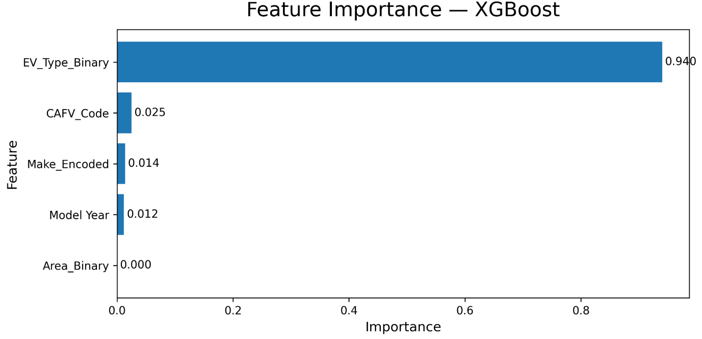
Figure 19 XGBoost feature importance.

5.20 Residual Analysis
In Figure 20, the distribution of the residuals (actual and predicted values) on the test set is shown in the XGBoost. The distribution is more or less symmetric and clustered around the zero, with the maximum on the zero-error line, which means that the model is unbiased on average. Distribution is leptokurtic with a narrow central peak and weak long tails making it appear that most of the predictions would lie within a narrow band of error with a small percentage of records giving a larger error. This trend is in line with the fact that the RMSE of 9.64 miles is slightly bigger than the MAE of 3.85 miles, which proves that a few misplaced predictions with large squared errors inflate the squared-error measure.
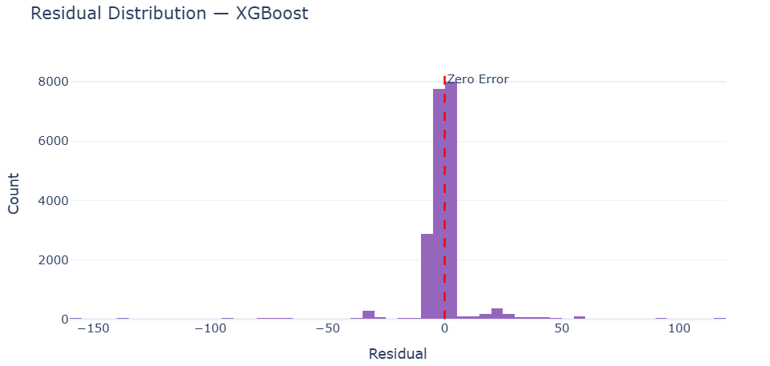
Figure 20 XGBoost residual distribution.

5.21 Web Application Deployment
The deployed interface of the Flask web application of the Battery Range Predictor tab is shown in Figure 21. The prediction displayed in the screenshot is that of a Tesla car with the registration date in 2023, which is a BEV, is in an Urban area and has CAFV Eligible status. The output of the model gave a predicted range of 284.1 miles, which is a range of the Long Range tier. The interface scales the range to a proportional bar scaled to the 337-mile maximum, shows a summary of the parameters that have been submitted, and shows model information such as the R 2 score of 0.9901 and the MAE of 3.85 miles. The six rapid-sample cards in the left panel can be auto-filled and predicted instantly, thus it is possible to show the model in various vehicle structures without typing out the data.
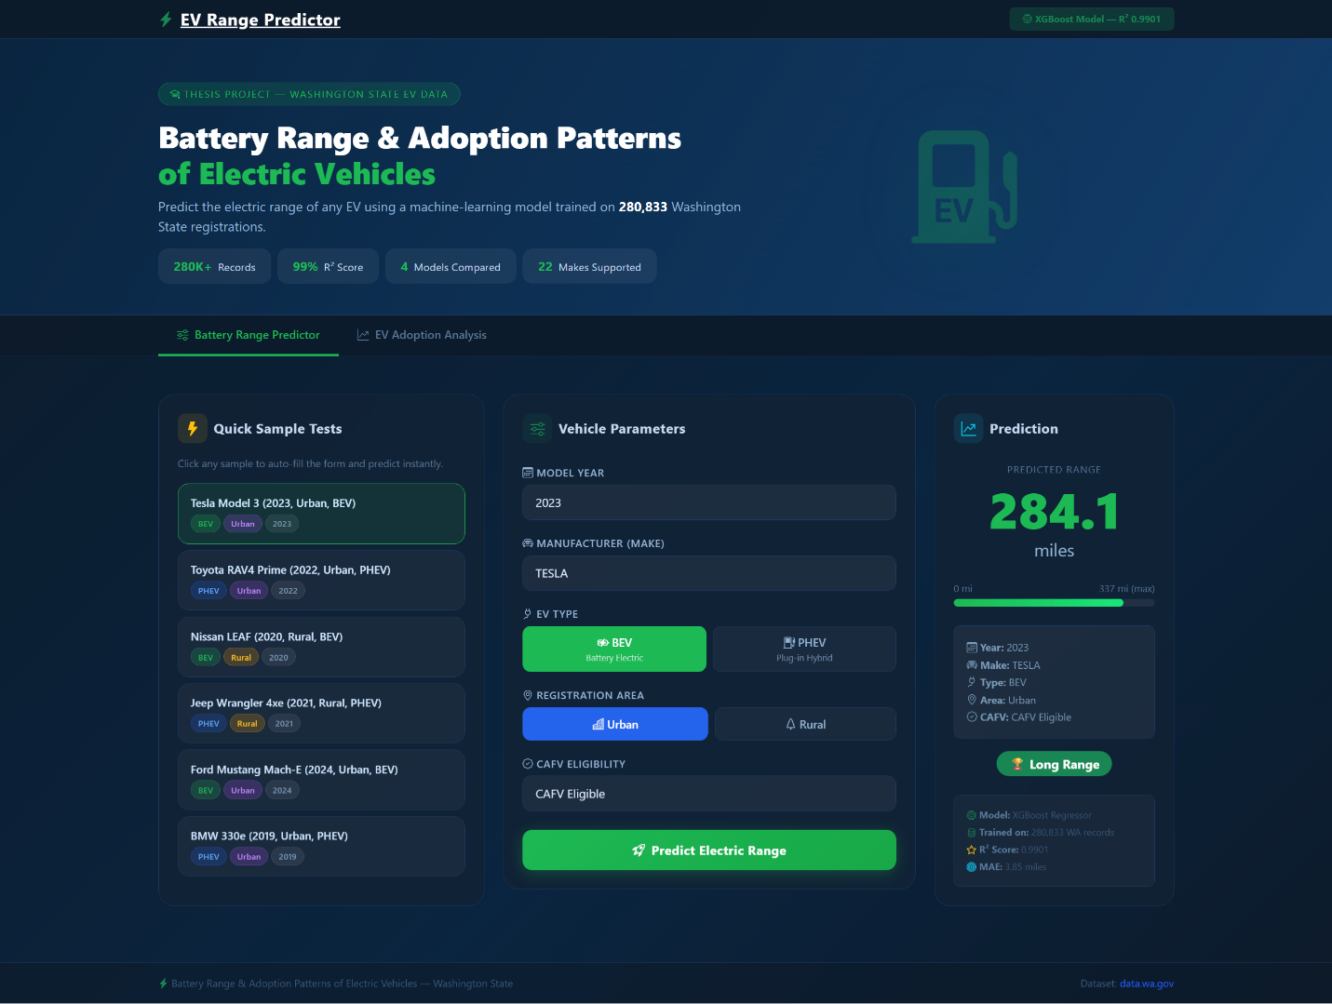
Figure 21 Web application predictor tab output.

CHAPTER 6: DISCUSSION

6.1 Discussion of Exploratory Results
The exploratory data analysis gives credence to a few patterns that are thoroughly established in the literature on adoption and reveal dataset-specific features that are useful in developing models. The high BEV share of 80.2% in Washington State registrations is indicative of how the state is highly advanced on the adoption diffusion curve as compared to national averages due to the long-term policy support and the disproportionate representation of Tesla, which is the sole source of 40.9% of all records (Forsythe et al., 2023). The 93.9-percentage of the concentration of registrations in urban areas is exactly the same as that of Hardaway et al. (2025), who claimed that the density of charging infrastructure and built environment features were the main structural factors of urban-rural adoption differentials. The rural disparity of 6.0% is a longstanding disparity that has not been bridged yet by state-level policy even with incentive programs reported by Mekky and Collins (2024).
The temporal trend analysis shows that there is a growth phase that is exponential between 2017 and 2023, with the highest number of registrations of 60,333 in model year 2023. The decrease in 2024 and 2025 registration numbers is not necessarily indicative of a reversal in adoption; it could be indicative of the way the data is collected, in that it records the vehicles registered at a single moment in time, but not the total number of vehicles sold over the years. Registration information is a flow variable that is vulnerable to deregistration and vehicle age loss, i.e., the apparent decrease at the boundary of the dataset should be viewed with a grain of salt (Zhao et al., 2023).

6.2 Trend and Composition Effects of the Average Range
Whether there is an average range trend is a significant result that should be interpreted with caution. The average range also increases consistently since the 71.8 miles in 2011 to 238.2 miles in 2020, which is also in agreement with H4 and the trend of technological development reported by Forsythe et al. (2023). This drastic drop to 52.0 miles in 2021 and the subsequent low values through 2025 is indicative of a dataset composition effect and not a regression in battery technology. Since 2021, significantly more PHEV registrations have started to record range values in the Washington State database, moving the denominator of the annual average range to the left of the PHEV range distribution. When the BEV subset is analysed separately, the mean range of 199.96 miles and median of 215 miles indicates that BEV range performance is high and it keeps up with further technological progress.

6.3 Model Performance and Selection
The fact that the Linear Regression (R2=0.7772, RMSE=45.72 miles) and the three tree-based models (R2>0.989, RMSE<9.85 miles) differ in their performance, gives a very good empirical evidence of the fact the relationship between vehicle attributes and electric range is essentially nonlinear. The two most important features (in terms of importance), which are categorical (manufacturer identity and EV type) are what introduce discrete cluster boundaries in the feature space that cannot be sufficiently modeled using linear regression. Label-encoded categorical variables arbitrarily ordinate the difference between categories, contrary to the assumption of continuous and proportional predictor effects in the linear model, which results in systematic prediction error at the boundary between the two categories of BEV and PHEV (Kaya, 2025).
The choice of XGBoost over Random Forest can be explained by its higher RMSE at 9.64 miles compared to 9.80 miles of random Forest, although the MAE of XGBoost is slightly higher at 3.85 miles compared to 3.75 miles in the case of the random Forest. The difference in RMSE indicates that XGBoost has an edge over Random Forest in that the former attempts to correct large residuals by the sequential construction of trees, while the latter attempts to reduce variance by averaging but does not attempt to directly correct residuals (Achariyaviriya et al., 2023). In an application in which the consequences of large rather than small prediction errors are of greater consequence, the smaller RMSE of XGBoost is more operationally relevant performance benefit.

6.4 Feature Importance Implications
The fact that the importance of the feature of MakeEncoded largely surpasses the other features is a confirmation that the identity of the manufacturer encodes a large percentage of the range information in the dataset, which serves as a proxy to the manufacturers level of investment in battery technology, the composition of the product portfolio and the positioning of the target market. The differentiation that this feature represents is the difference between the Tesla mean range of 241.5 miles and the 199.96 miles that the dataset mean range of BEVs is. The EV_Type_Binary is ranked second to strengthen the basic BEV-PHEV difference as the key structural difference in the target variable distribution. The fact that the significance of Area_Binary is relatively low is also worth mentioning: the area type leads to prediction by serving as the correlation between the type of vehicles that are registered in the specific geographic area (rather than by direct physical connection between the geographic location and battery range). The result aligns with Hardaway et al. (2025), stating that geographic impacts on EV outcomes do not work via physical mechanisms on vehicle specifications but through mediating variables such as income, infrastructure availability, and product availability.

6.5 Application Deployment Validation
The deployments of the Flask application confirm the full pipeline of raw data to trained model to inference in real-time. The forecast of 284.1 miles of a 2023 Tesla BEV in an Urban area has CAFV Eligible is in line with the established range profiles of the Tesla 2023 product line, with 272 to 358 miles being the EPA-estimated range of the Model 3 Long Range and Model Y Long Range versions. The fact that the model output is classified as Long Range above the 250-mile mark further indicates that the model output is in line with the actual manufacturer specifications. The analysis of adoption avenue offers further research benefit by allowing a longitudinal analysis of the registration data as per their area type and years range that goes beyond the use of the application to predict a single vehicle to the analysis of the policy related trends.

6.6 Fit to Research Questions
RQ1 is answered: yes, the five attributes of vehicles chosen predict the electric range with a significant high level of accuracy, and this is much higher than the R 2 0.85 level indicated in H1. RQ2 is partially confirmed: EV adoption has increased steadily in fiscal years 2017 2026 in Washington State, and the urban-rural difference that is reported in both primary EV dataset and the registration dataset supports H3. RQ3 is well addressed in favor of XGBoost both in terms of R² and RMSE.

CHAPTER 7: CONCLUSION, LIMITATIONS, AND FUTURE WORK

7.1 Conclusion
The objective of this study was to explore two related aspects of the dynamics of electric vehicles in Washington State; prediction of battery range based on vehicle registration characteristics and longitudinal study of EV adoption patterns in urban and rural geographic categories. The two goals were met with a combined supervised machine learning and an interactive Web application based on an integrated analytical platform that was trained and validated using two large-scale public datasets based on the Washington State Department of licensing.
According to the exploratory data analysis, it was determined that Battery Electric Vehicles take up 80.2% of the total number of 280,833 registered vehicles in the primary dataset with Tesla constituting 40.9% of all the registered vehicles. Urban areas are much more heavily concentrated with the geographic distribution of 93.9 and King County alone comprising 49.2 of all registrations. Its trend of adoption is exponential with a low of 573 registered in model year 2011 up to a high of 60,333 in 2023, similar to the patterns of adoption observed in the overall adoption literature (Jung et al., 2023). The gap between urban and rural adoption is also vast and entrenched and the rural registrations have not yet reached 4,000 in the whole 2011-2025 period in spite of the continuous growth in the urban segment.
The machine learning part shows that XGBoost regression is the most precise model to predict the electric range using the five features chosen, with the R 2 of 0.9901, MAE of 3.85 miles and RMSE of 9.64 miles on a held-out test of 20241 records. These findings confirm hypothesis H2, where XGBoost outperforms Linear Regression, Decision Tree and random forest based on the R 2 and RMSE values. The empirical validation of the range prediction task being fundamentally nonlinear, with an RMSE of 45.72 and 9.64 miles of the Linear Regression and all of the tree-based models, respectively, are the fact that the range prediction task cannot be adequately represented using parametric linear techniques because of this range feature structure.
The analysis of feature importance shows that the manufacturer identity is the most significant predictor, then EV type, CAFV eligibility, model year, and area classification. This ranking is based on the dynamics of EV range differentiation in the real world, where the main drivers of the range values that are registered in state registrations are the investment of the manufacturer in the battery and the composition of the product portfolio. The third-place ranking of the CAFV eligibility feature demonstrates its usefulness as a range-informative proxy by putting the state regulatory classification of vehicle range performance into the model.
The Flask web application manages to operationalize the trained XGBoost model, which makes real-time predictions of the range depending on any combination of the 22 supported manufacturers, model years (1990 to 2030), EV type, area classification and CAFV eligibility. The 284.1 miles forecast of a Tesla BEV with CAFV Eligible status in an Urban area is in line with the range profiles recorded by Tesla, confirming the usefulness of the deployed model. The application enabling the interactive search of the Washington State registration data including the fiscal years 2017 through 2026 by area type is a continuation of the application academic contribution by revealing the practical nature of the analytical framework to policy-oriented stakeholders.
Overall, the research has three contributions to the current literature in EV research: it makes high-accuracy machine learning model, which is explicitly calibrated on population-level Washington State registration data; it quantifies an urban-rural adoption gap using both vehicle-level and county-level registration data; and it exemplifies a deployable web-based platform, which bridges the gap between academic modeling and practical accessibility.

7.2 Limitations
The findings are limited by a number of constraints to the scope and generalizability.
To begin with, the prediction target is the electric range reported by manufacturers and is found in the state registration database and not dynamically measured real-world range. In the unfavorable conditions such as cold weather, high-speed motorway, and aggressive acceleration profiles, the actual driving range is lower than the reported values (Cui et al., 2022; Cervini et al., 2024). This model thus forecasts a fixed specification as opposed to the range that a driver would experience under certain operating conditions and hence is not useful in trip planning applications.
Second, the data of the urban-rural imbalance used in the modeling (80-20) implies that the XGBoost model is mostly trained on the urban vehicle configurations. The number of rural records is only 16,910 out of the 280,833 total registrations, and when this is further narrowed down to reported range, this ratio decreases even more in the training set. The accuracy of prediction of rural-registered vehicles might be less than the overall test set results indicate, because the model has little experience with the specific combinations of vehicles most preferred in rural Washington State.
Third, the features are restricted to five attributes found in the registration database. Administrative dataset does not include variables that are known to affect range in practice such as ambient temperature, vehicle mileage, battery degradation state, driving style, and terrain (Cui et al., 2022). The model represents range potential at manufacturer and configuration level instead of range in specific instances.

7.3 Future Work
A number of recommendations towards further research arise out of this study.
The most effective extension would be the combination of actual range measurements of telematics or sensor data and the registered data. Achariyaviriya et al. (2023) showed that vehicle sensor data significantly enhance the accuracy of energy consumption prediction, and an analogous method used to predict range would overcome the shortcoming of predicting reported range, as opposed to experienced range. Adding ambient temperature data on the county level would also expand the range of the model to cold-weather range degradation cases discovered by Cervini et al. (2024).
The ZIP code level and not the county level spatial analysis would allow more specific analysis of the effects of the density of charging infrastructure on the adoption patterns. Esmaili et al. (2024) revealed a high level of intra-county disparity in King County charging equity, and the implementation of the framework of the analysis of the adoption to ZIP code resolution would enable the application to identify the disparities in adoption that are masked by a county-wide analysis.
The existing dichotomous urban-rural typology might be substituted with an urbanization index that is continuous based on population density, the density of the road network, or built environment indicators, which follows the paradigm of Hardaway et al. (2025). This would enable the model to represent geographic context gradations with more complexity than the binary encoding of such gradations is currently possible.
The machine learning part can be further developed with cross-validated grid search or Bayesian optimization that can further reduce RMSE than the already existing manually configured XGBoost setting. Also, the ensemble comparison would be completed by adding a Gradient Boosting Regressor comparison which was imported but not trained in the current notebook.
Lastly, longitudinal prediction features could be added to the web application to enable users to compare predicted ranges of a similar vehicle setup across various model years, thus displaying the interactive battery improvement curve. The county-level integration of the data on the density of the charging stations used by Esmaili et al. (2024) and Powell and Johnson (2024) would allow the adoption analysis tab to present the data on the infrastructure coverage in addition to the data on registration trends, which would form a more comprehensive evidence base of the policy-oriented users studying the structural determinants of the urban-rural disparity in adoption in Washington State.

References
Achariyaviriya, W., Wongsapai, W., Janpoom, K., Katongtung, T., Mona, Y., Tippayawong, N. and Suttakul, P., 2023. Estimating energy consumption of battery electric vehicles using vehicle sensor data and machine learning approaches. Energies, 16(17), p.6351.
Cervini, G., Jung, J. and Gkritza, K., 2024. Temperature and electric vehicle adoption: A ZIP code-level analysis in the US. Transportation Research Part D: Transport and Environment, 136, p.104435.
Cui, D., Wang, Z., Liu, P., Wang, S., Zhang, Z., Dorrell, D.G. and Li, X., 2022. Battery electric vehicle usage pattern analysis driven by massive real-world data. Energy, 250, p.123837.
Eby, D.W., St. Louis, R.M., Zakrajsek, J.S. and Zanier, N., 2025. Adoption and Use of Battery Electric Vehicles Among Older Drivers: A Review and Research Recommendations. Sustainability, 17(7), p.2810.
Esmaili, A., Oshanreh, M.M., Naderian, S., MacKenzie, D. and Chen, C., 2024. Assessing the spatial distributions of public electric vehicle charging stations with emphasis on equity considerations in King County, Washington. Sustainable Cities and Society, 107, p.105409.
Forsythe, C.R., Gillingham, K.T., Michalek, J.J. and Whitefoot, K.S., 2023. Technology advancement is driving electric vehicle adoption. Proceedings of the National Academy of Sciences, 120(23), p.e2219396120.
Gehrke, S.R. and Reardon, T.G., 2022. Patterns and predictors of early electric vehicle adoption in Massachusetts. International Journal of Sustainable Transportation, 16(6), pp.514-525.
Gifford, T. and Barbier, E.B., 2025. Commuting Time, Charging Infrastructure, and Electric Vehicle Adoption for Sustainable Transportation: A Case Study of Washington State. Sustainability, 17(21), p.9591.
Gustafson, A. and Clark, H.R., 2026. The Environment Takes a Back Seat: A Content Analysis of Persuasive Appeals in Electric Vehicle Advertisements. Sustainability, 18(9), p.4286.
Hardaway, K., Genc, U., Cai, H. and Nateghi, R., 2025. Electric vehicle adoption and planning: The increasing importance of the built environment. Journal of Transport Geography, 123, p.104115.
Henderi, H., Zailani, A.U., Tuah, N.M. and bin Abas, A., 2025. Segmentation and Profiling of Electric Vehicle Market Using Clustering Analysis: A Case Study with Implications for Digital Marketing in the EV Sector. Journal of Digital Market and Digital Currency, 2(3), pp.323-342.
Jung, F., Schröder, M. and Timme, M., 2023. Exponential adoption of battery electric cars. PLoS one, 18(12), p.e0295692.
Kaya, H., 2025. An analysis of market size trends forecasting and range prediction in Electric Vehicles using machine learning algorithms. Turkish Journal of Forecasting, 9(1), pp.7-16.
Lee, D.Y., Wilson, A., McDermott, M.H., Sovacool, B.K., Kaufmann, R., Isaac, R., Cleveland, C., Smith, M., Brown, M. and Ward, J., 2025. Does electric mobility display racial or income disparities? Quantifying inequality in the distribution of electric vehicle adoption and charging infrastructure in the United States. Applied Energy, 378, p.124795.
Lukuyu, J., Shirley, R. and Taneja, J., 2024. Managing grid impacts from increased electric vehicle adoption in African cities. Scientific Reports, 14(1), p.24320.
Mekky, M.F. and Collins, A.R., 2024. The Impact of state policies on electric vehicle adoption-A panel data analysis. Renewable and Sustainable Energy Reviews, 191, p.114014.
Mpoi, G., Milioti, C. and Mitropoulos, L., 2023. Factors and incentives that affect electric vehicle adoption in Greece. International journal of transportation science and technology, 12(4), pp.1064-1079.
Powell, B. and Johnson, C., 2024. Impact of electric vehicle charging station reliability, resilience, and location on electric vehicle adoption (No. NREL/TP--5R00-89896). National Renewable Energy Laboratory (NREL), Golden, CO (United States).
Samawi, G.A., Bwaliez, O.M., Jreissat, M. and Kandas, A., 2025. Advancing sustainable development in Jordan: a business and economic analysis of electric vehicle adoption in the transportation sector. World Electric Vehicle Journal, 16(1), p.45.
Qian, X. and Gkritza, K., 2024. Spatial and temporal variance in public perception of electric vehicles: A comparative analysis of adoption pioneers and laggards using twitter data. Transport Policy, 149, pp.150-162.
Sinton, J., 2022. Factors Affecting Electric Vehicle Adoption at the ZIP Code Level (Master's thesis, Purdue University).
Wong, D.W., Zhang, F., Siddiki, S.N. and Yang, C., 2025. Spatial variabilities in factors affecting electric vehicle adoption across Virginia: A county-level analysis. Applied Geography, 178, p.103600.
Yu, J., 2025. Research on Analysis and Prediction of Electric Vehicle Ownership in Washington State, USA, Based on Data Science Technologies. Computer Science, 4(3).
Zaino, R., Ahmed, V., Alhammadi, A.M. and Alghoush, M., 2024. Electric vehicle adoption: A comprehensive systematic review of technological, environmental, organizational and policy impacts. World electric vehicle journal, 15(8), p.375.
Zhao, L., Ottinger, E.R., Yip, A.H.C. and Helveston, J.P., 2023. Quantifying electric vehicle mileage in the United States. Joule, 7(11), pp.2537-2551.

